**NATIONAL INSTITUTE OF** **TECHNOLOGY, TIRUCHIRAPPALLI**



**“VOICE-BASED CALCULATOR”**

**Under the Guidance: Submitted By:**

**Dr. S.R. Balasundaram Sir Himanshu Sathe (205121043)**

**Nikhil Chawre (205121063)**

**Table of Contents**

1. **Introduction**
   * 1. Problem Title
     2. Objective
     3. Purpose
     4. Scope
     5. Description
2. **Data Flow Diagram**
3. **Modules**

**Introduction**

The **Voice-Based Calculator** uses the Web Speech API to recognize the user's voice commands and perform the corresponding operation.

We developed this project under the guidance of our faculty guide **Dr. S.R. Balasundaram sir** and our team consists of two members **Himanshu Sathe (205121043)** and **Nikhil Chawre (205121063).** We created this project as part of our summer intern under our guide.

**1.1 Problem Title**

**"Voice-Based Calculator"** using JavaScript and Web Speech API.

It involves the design and development of a calculator that allows users to perform basic arithmetic operations using their voice and manually too.

**1.2 Objective**

The objectives of the project are as follows:

1. To design and develop a voice-based calculator using JavaScript and the Web Speech API.
2. To provide users with an alternative and accessible method for performing basic arithmetic operations.
3. To improve the user experience and convenience of the calculator by reducing the need for manual input, thus allowing users to perform calculations hands-free.
4. To develop a functional and reliable calculator that performs arithmetic operations efficiently, using both voice commands and button input.
5. To provide a simple and user-friendly tool that can be used by anyone.

**1.3 Purpose**

The purpose of this project is to create a voice-based calculator using JavaScript. The calculator will allow users to perform basic arithmetic operations manually and by speaking the commands to the calculator.

**1.4 Scope**

The scope of the project is to design, develop, and evaluate a voice-based calculator using JavaScript and the Web Speech API. The project will involve the following tasks:

User interface design: The user interface will be designed to be simple and easy to use, with buttons for basic arithmetic operations and a microphone icon for voice commands.

Speech recognition functionality: The Web Speech API will be used to capture the user's voice commands and convert them into text. The text will then be processed to determine the operation to be performed and the operands involved.

Arithmetic operation logic: The basic arithmetic operations (addition, subtraction, multiplication, and division) will be supported. The logic for performing these operations will be implemented using JavaScript.

Clear functionality: The calculator will include a clear button for resetting the calculator screen.

**1.5 Description**

This calculator is built using HTML, CSS, and JavaScript, and it uses the Web Speech API to recognize voice commands and perform calculations.

Our calculator supports basic arithmetic operations such as addition, subtraction, multiplication, and division. You can use it to perform calculations hands-free, which makes it ideal for situations where you don't have access to a keyboard or mouse.

To use the calculator, simply click on the microphone icon and speak your command. For example, you can say "two plus two" to perform the addition operation, or "five multiply ten" to perform multiplication. The calculator will display the result on the screen, and you can continue using it to perform additional operations.

We hope you find our Voice-Based Calculator useful and easy to use.

**CONTEXT LEVEL DATA FLOW DIAGRAM**

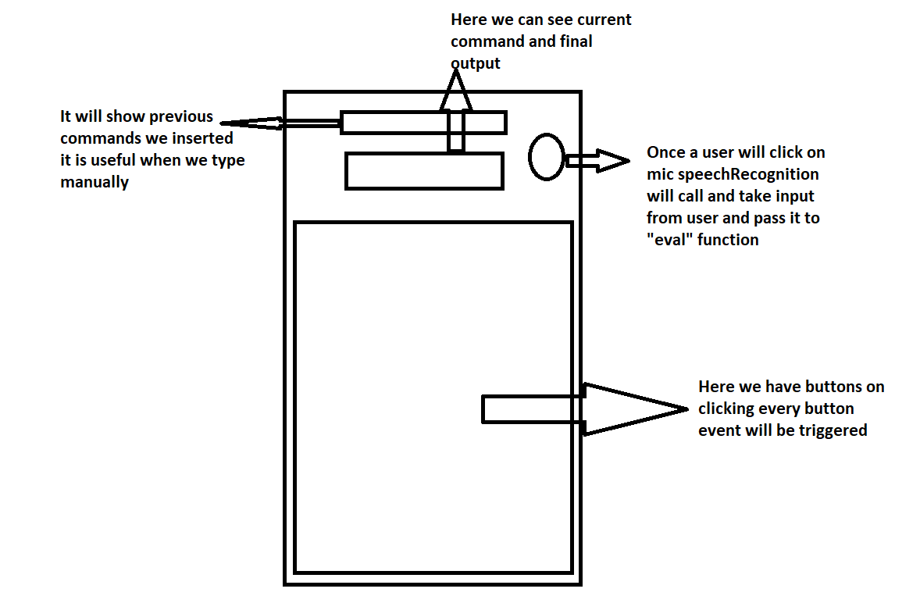

**MODULES:**

**Index.html Page:** Here we have written code for taking input from user manually and using voice command, once user click on microphone an event will be trigger and then command will be taken and evaluated with the help of web speech API.

**About.html Page:** Here we have written about the purpose of our project, about our guide, and limitations of our project and how we built it, in short.

**Instruction.hmtl Page:** Here we have written some points about how someone can use it and how they can perform basic arithmetic operations.

**Style.css:** It is used to give styling to our front-end portion.

**Script.js Page:** It is main file of our project, here we have written whole logic behind the each operations performed manually or by voice.